# JIT and Lean Production: Precedence Network

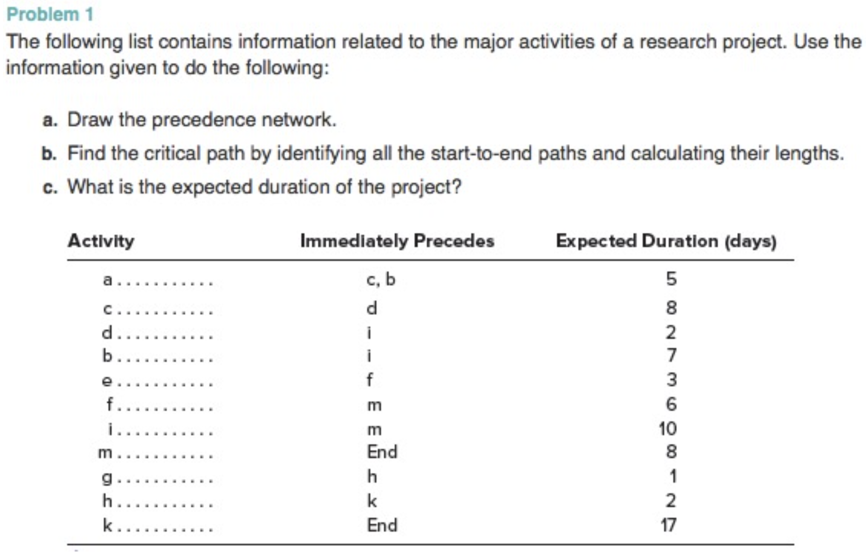

1. Precedence network:

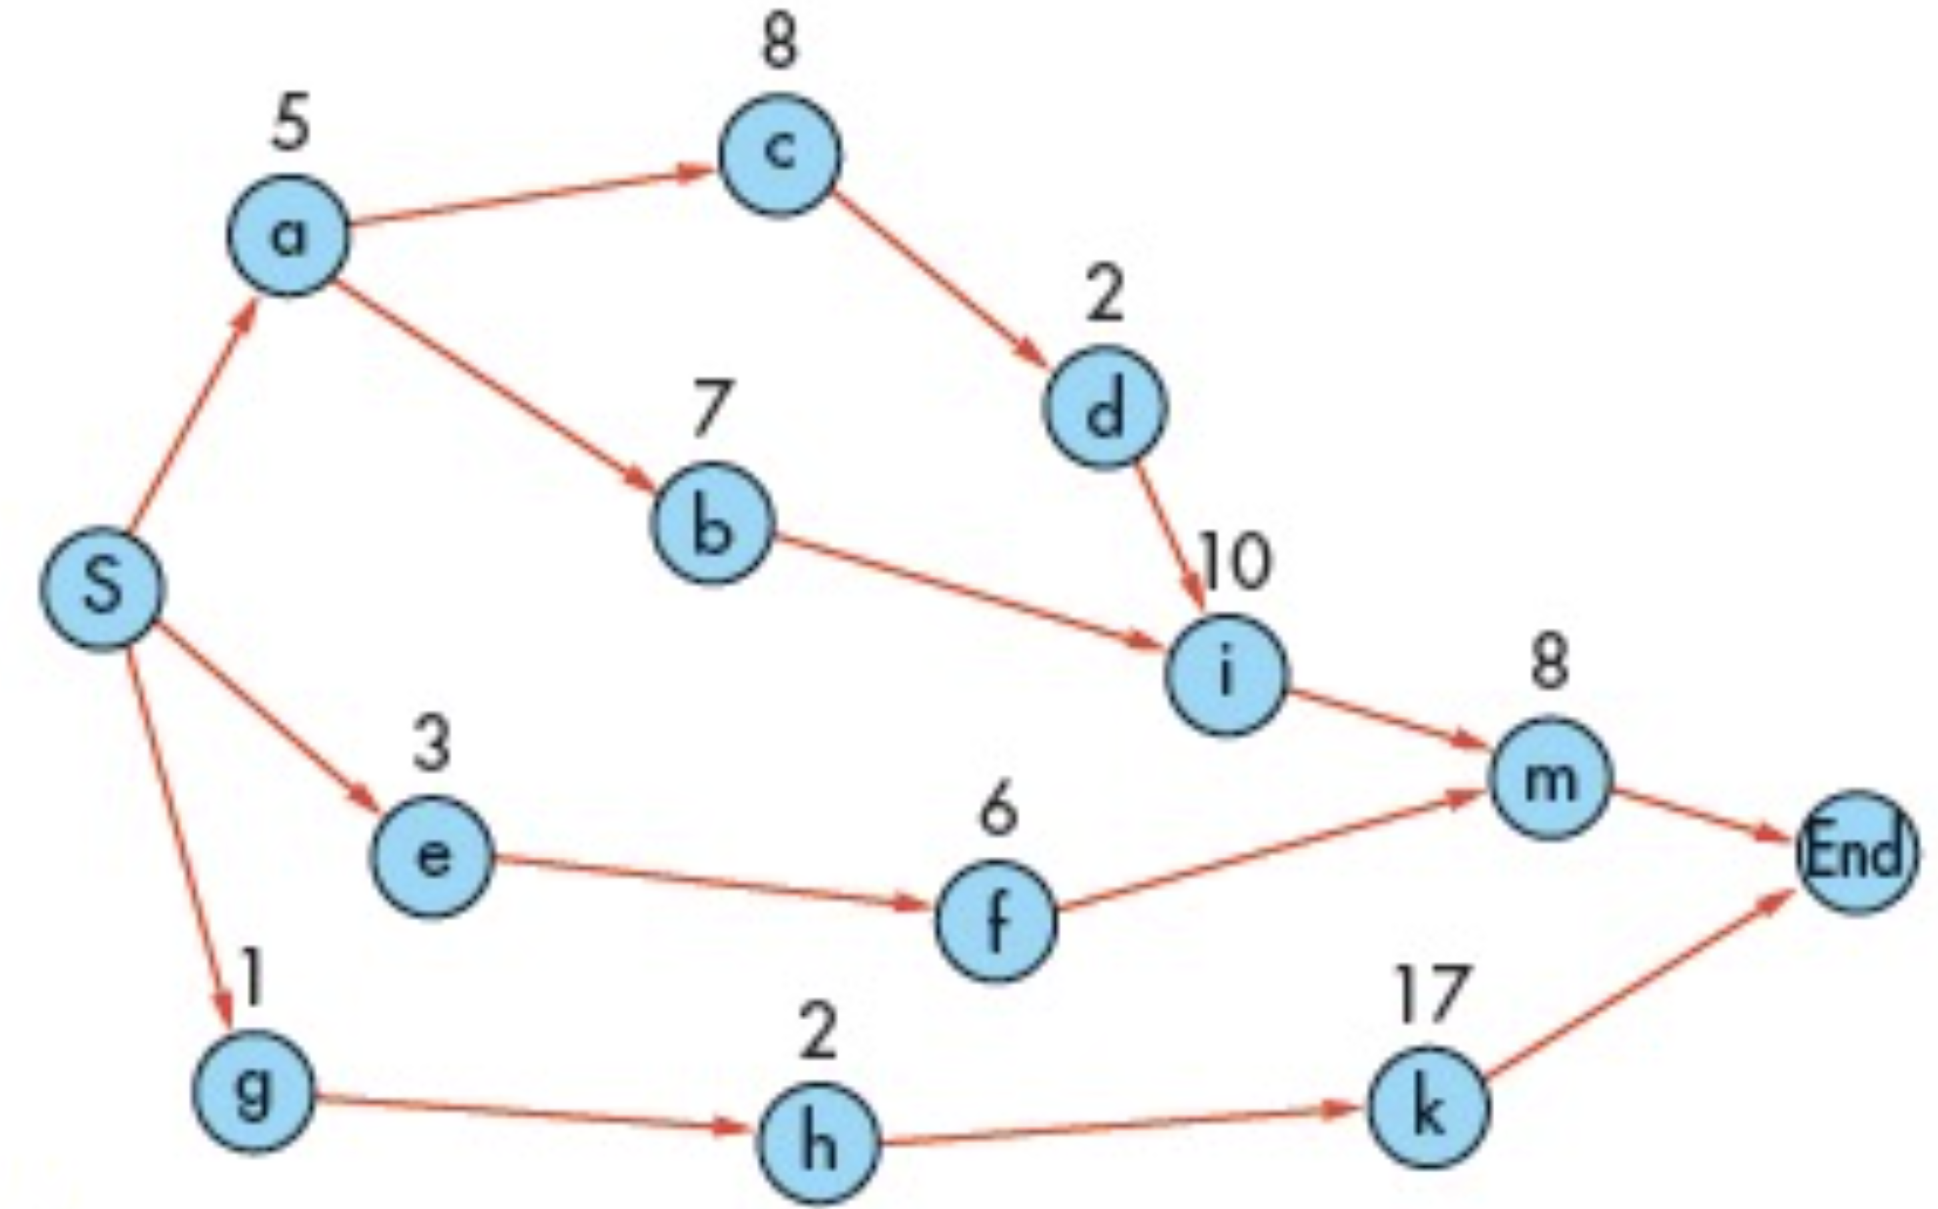

1. Critical path:

|  |  |
| --- | --- |
| **Path** | **Length (days)** |
| $$S-a-c-d-i-m-End$$ | $$5+8+2+10+8=33$$ |
| $$S-a-b-i-m-End$$ | $$5+7+10+8=30$$ |
| $$S-e-f-m-End$$ | $$3+6+8=17$$ |
| $$S-g-h-k-End$$ | $$1+2+17=20$$ |

Critical path: $S-a-c-d-i-m-End$.

1. Expected duration:

Expected project duration $=33$ days.

# JIT and Lean Production: PERT/CPM, Slack Times

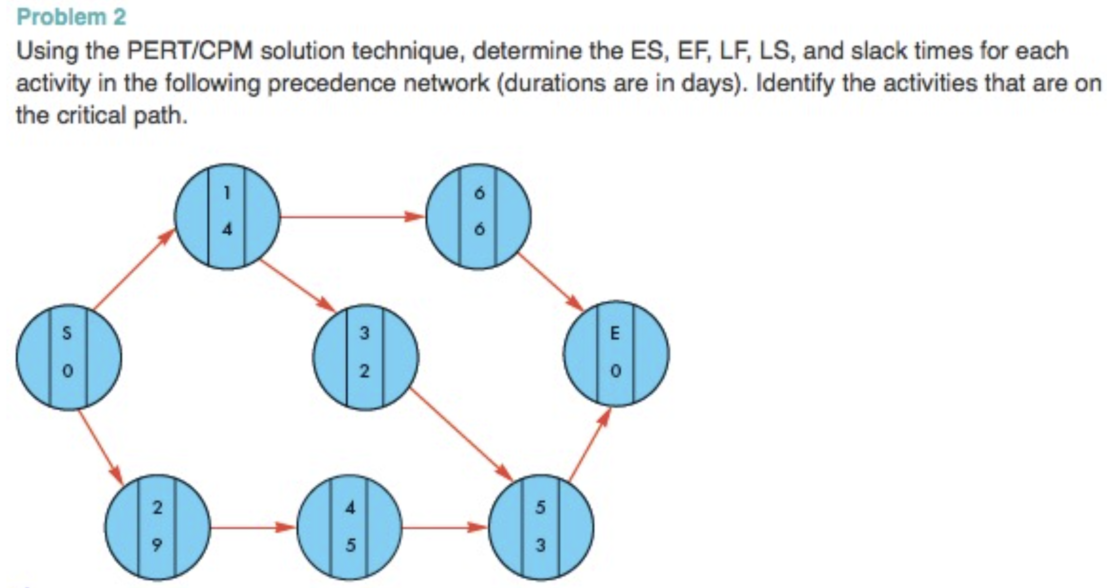

Determine and place the ES, EF, LS, and LF times for each activity in its circle as follows:

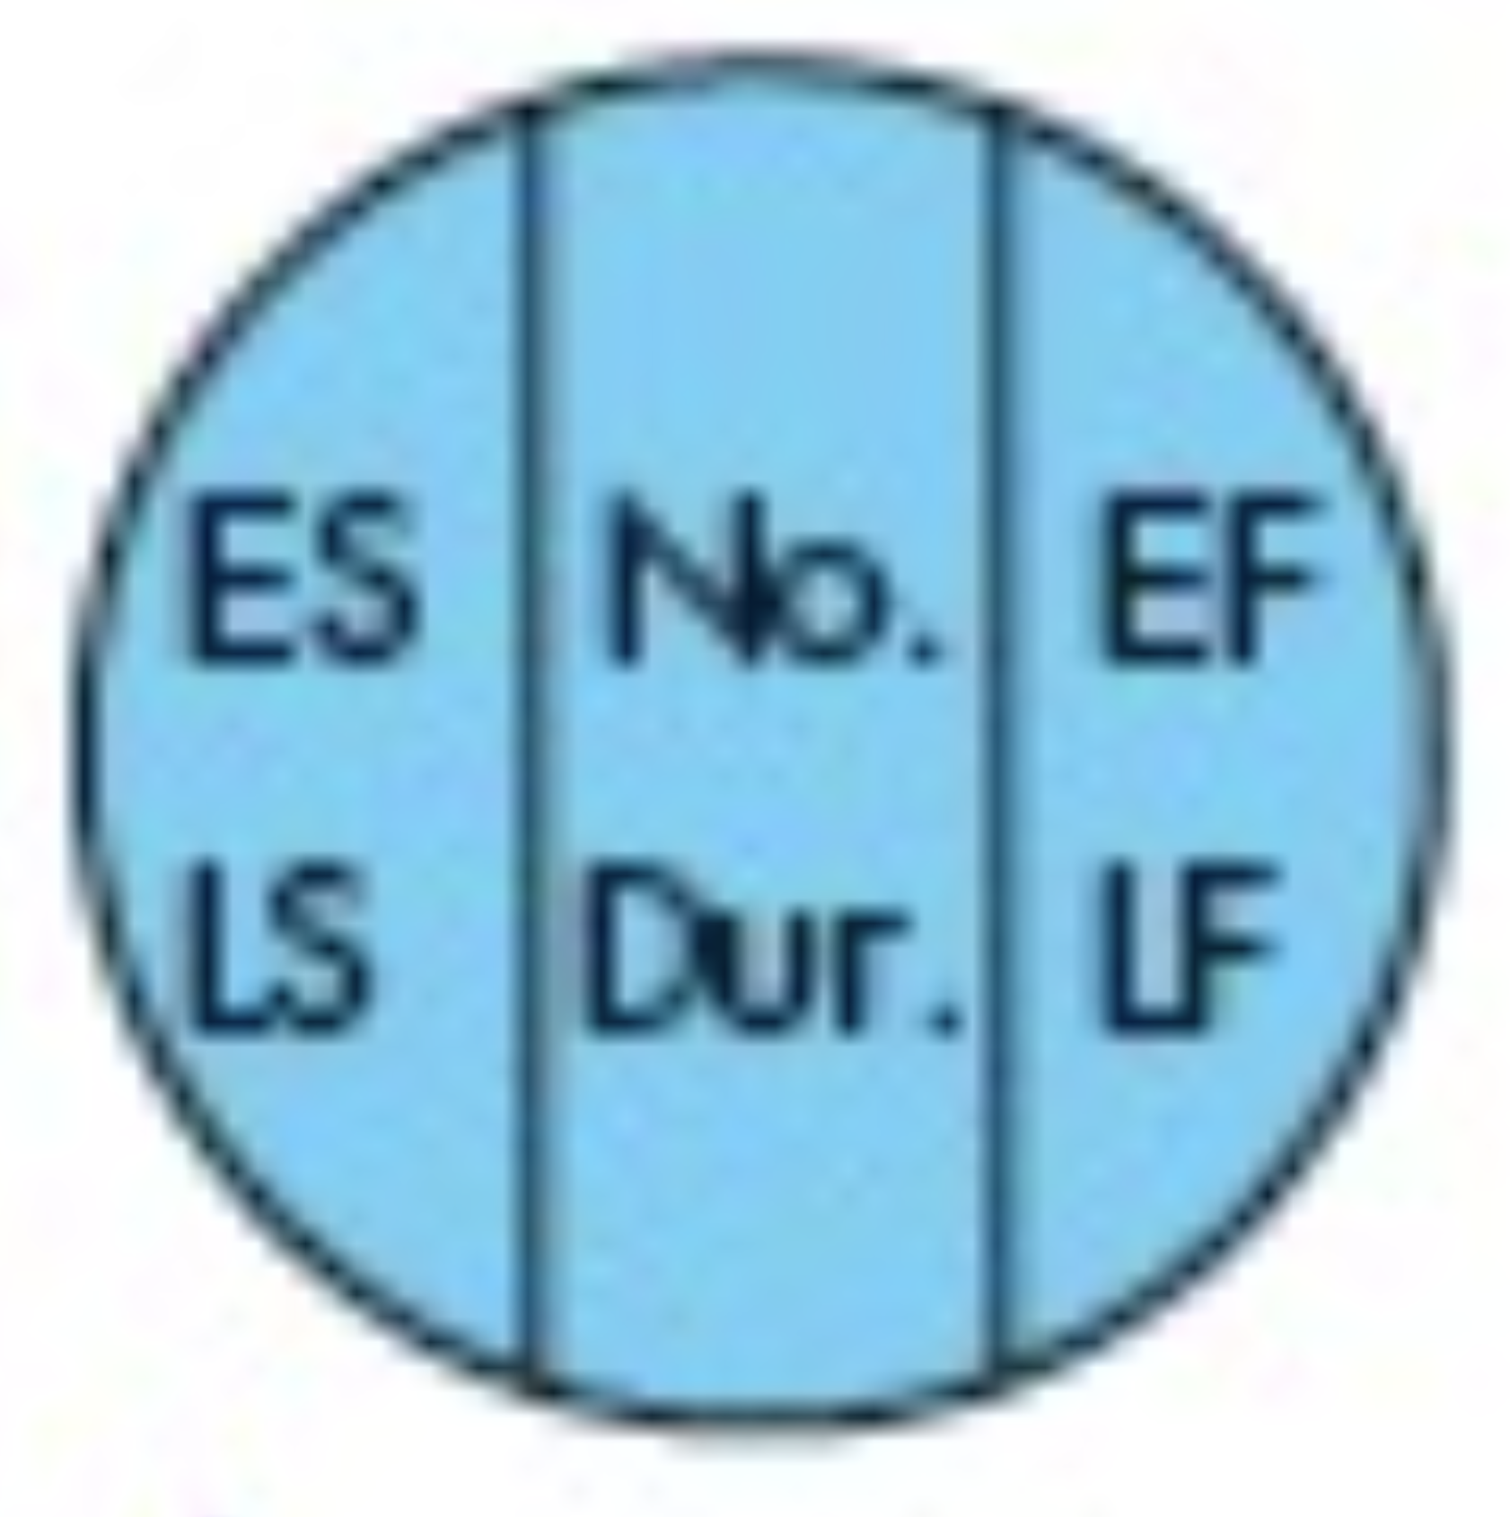

Forward pass to get ES and EF:

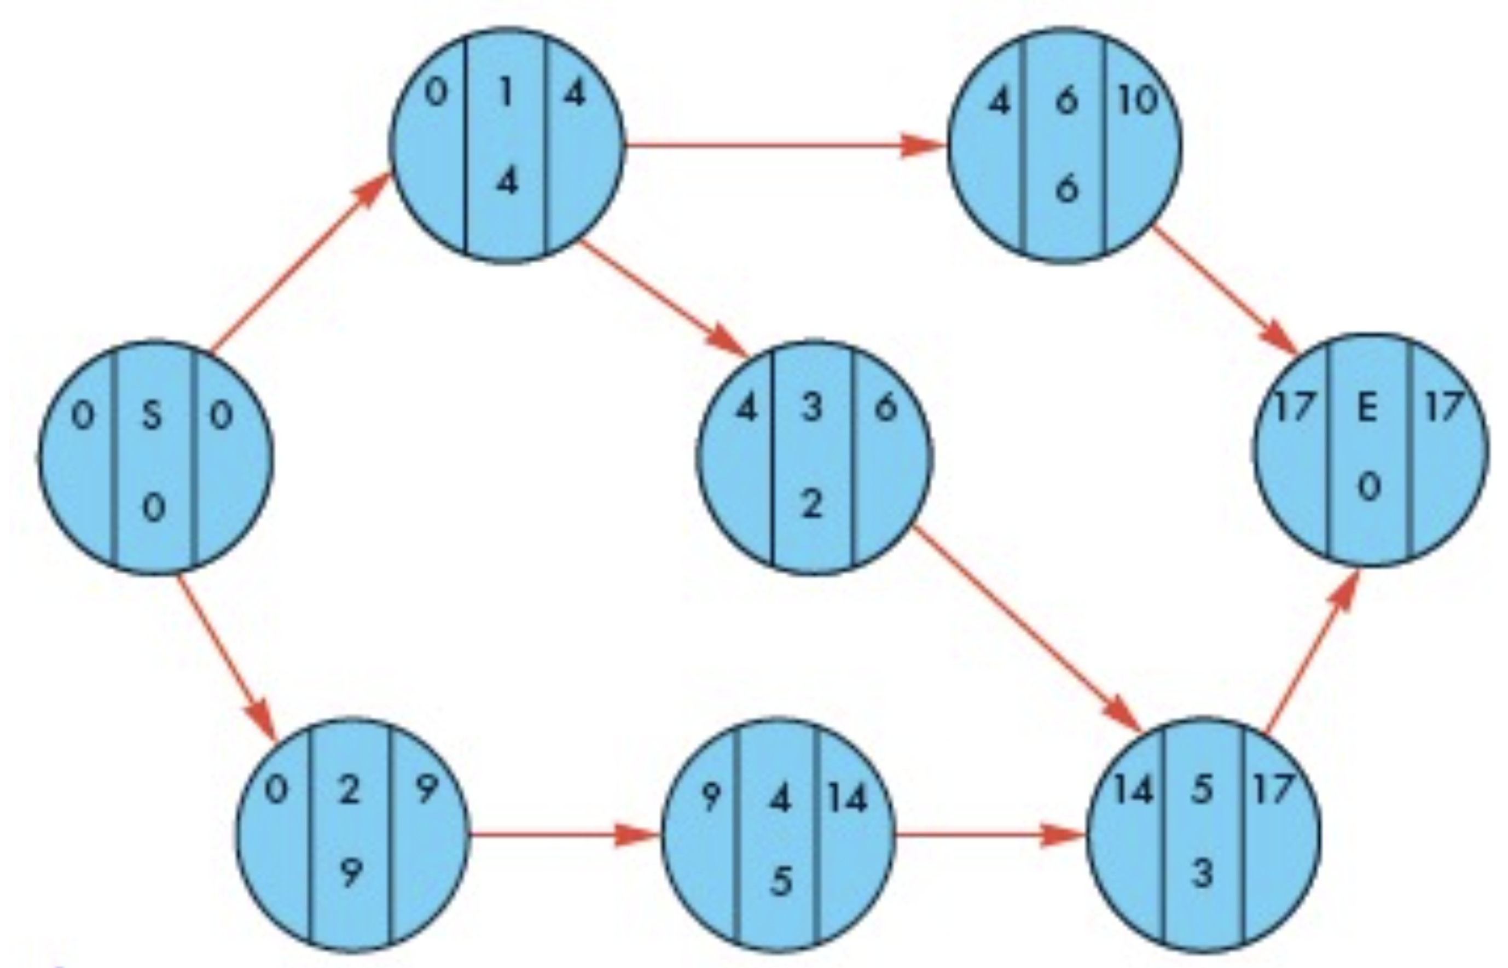

Backward pass to get LS and LF:

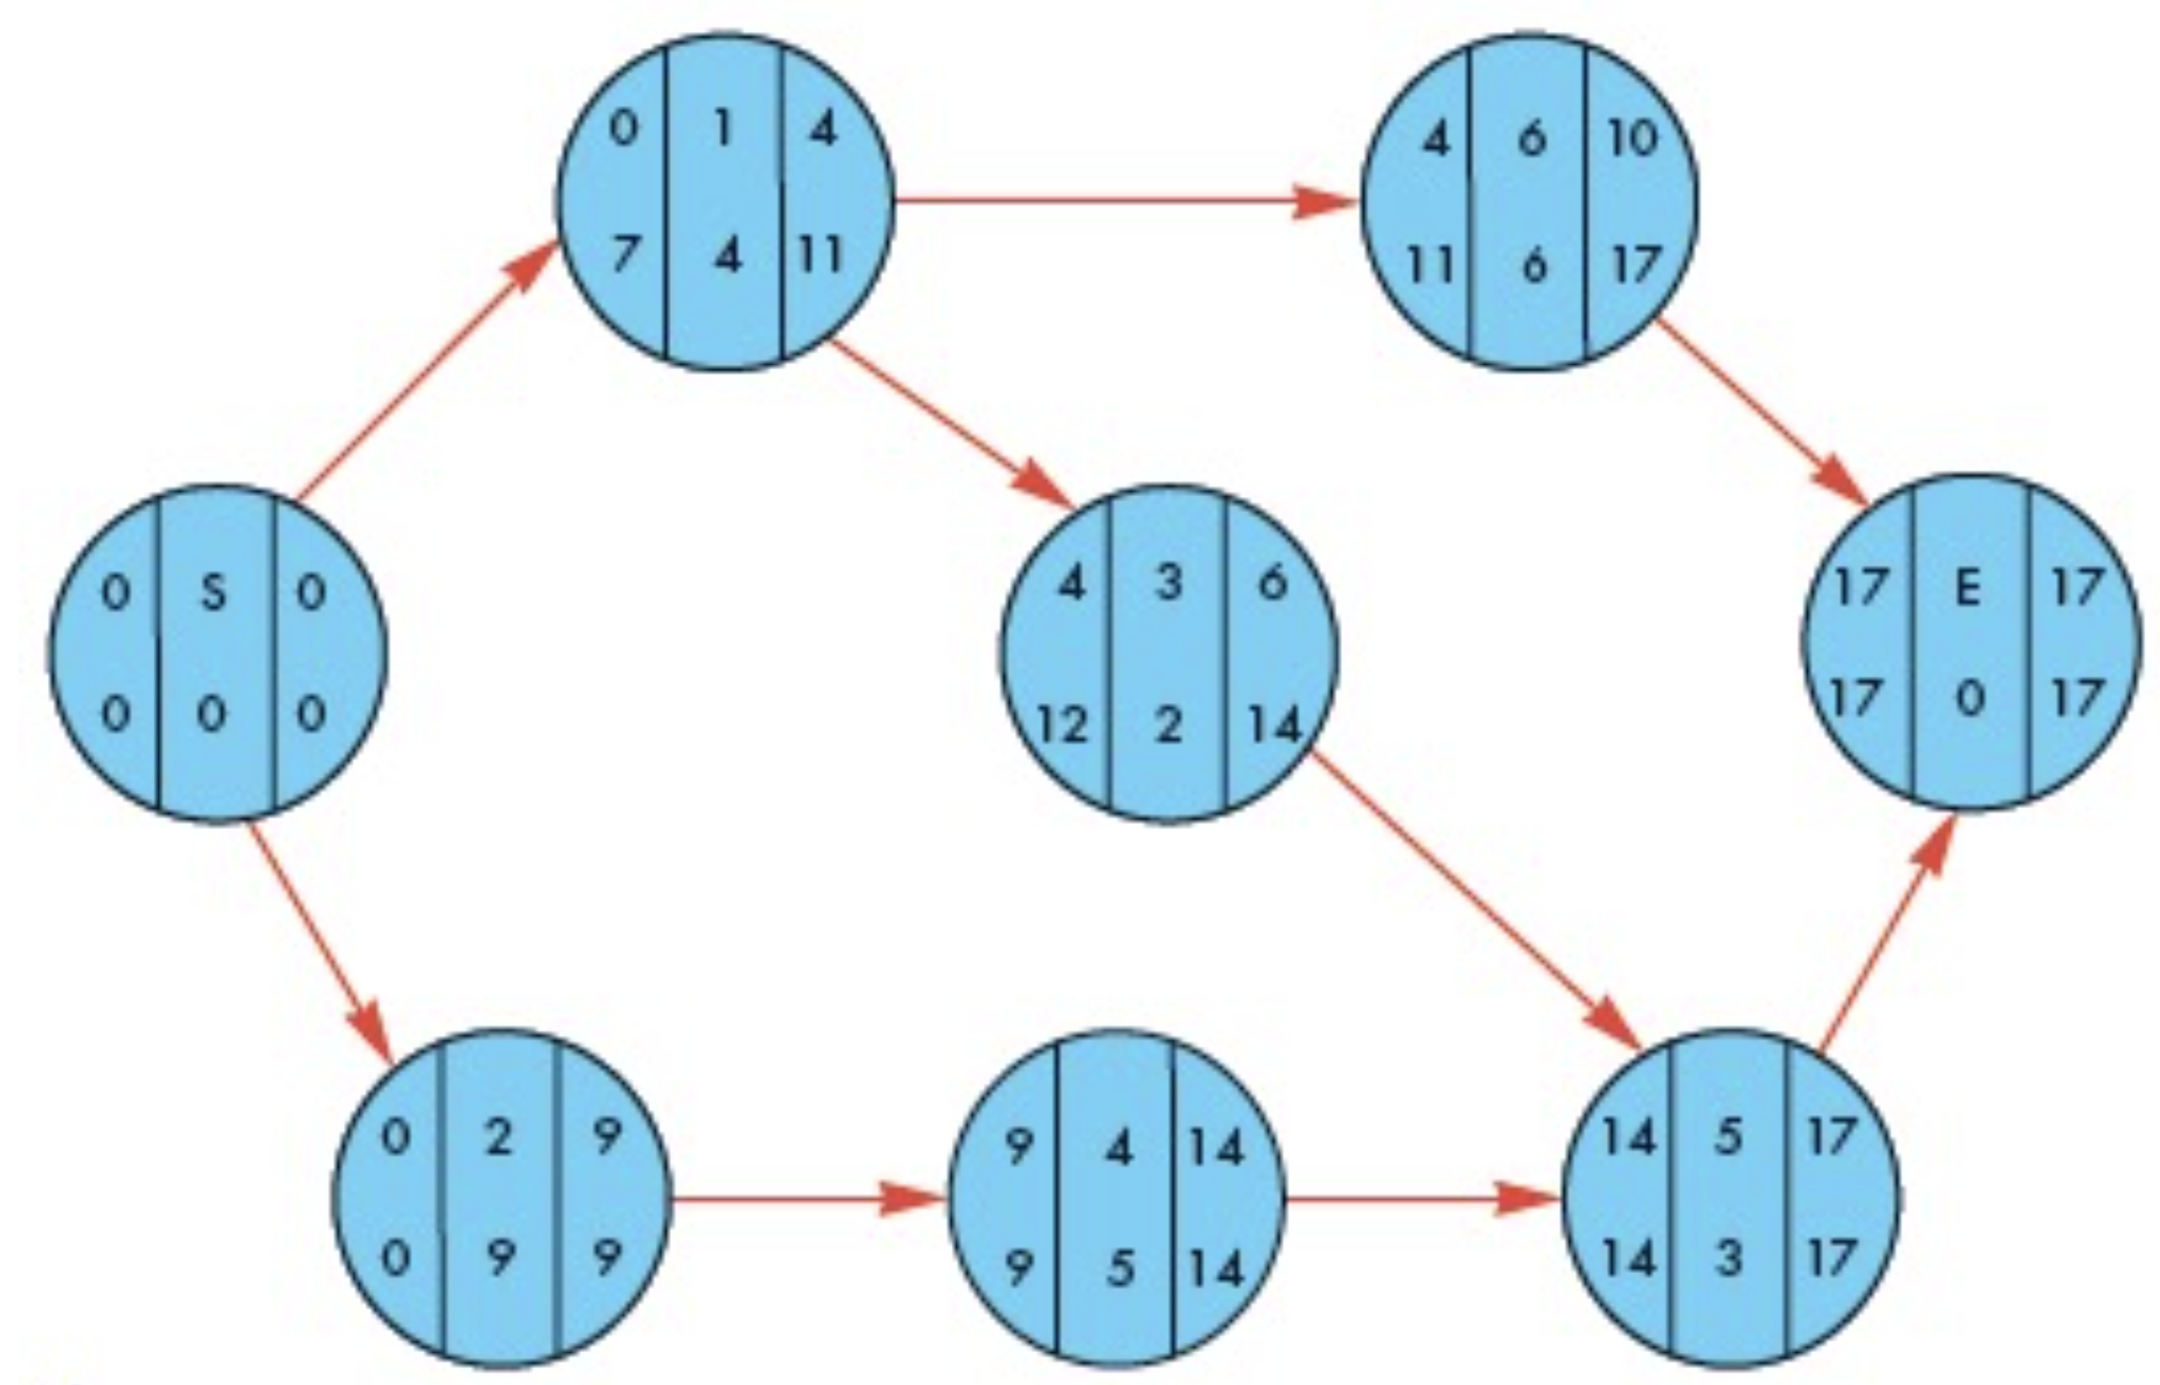

The slack time for an activity is the difference between either LF and EF or LS and ES. Thus,

|  |  |  |  |  |  |  |  |
| --- | --- | --- | --- | --- | --- | --- | --- |
| **Activity** | **LS** | **ES** | **Slack** | **or** | **LF** | **EF** | **Slack** |
| $$S$$ | $$0$$ | $$0$$ | $$0$$ |  | $$0$$ | $$0$$ | $$0$$ |
| $$1$$ | $$7$$ | $$0$$ | $$7$$ | $$11$$ | $$4$$ | $$7$$ |
| $$6$$ | $$11$$ | $$4$$ | $$7$$ | $$17$$ | $$10$$ | $$7$$ |
| $$3$$ | $$12$$ | $$4$$ | $$8$$ | $$14$$ | $$6$$ | $$8$$ |
| $$2$$ | $$0$$ | $$0$$ | $$0$$ | $$9$$ | $$9$$ | $$0$$ |
| $$4$$ | $$9$$ | $$9$$ | $$0$$ | $$14$$ | $$14$$ | $$0$$ |
| $$5$$ | $$14$$ | $$14$$ | $$0$$ | $$17$$ | $$17$$ | $$0$$ |
| $$E$$ | $$0$$ | $$0$$ | $$0$$ | $$0$$ | $$0$$ | $$0$$ |

Critical path: $S-2-4-5-E$

# JIT and Lean Production: Kanban 1

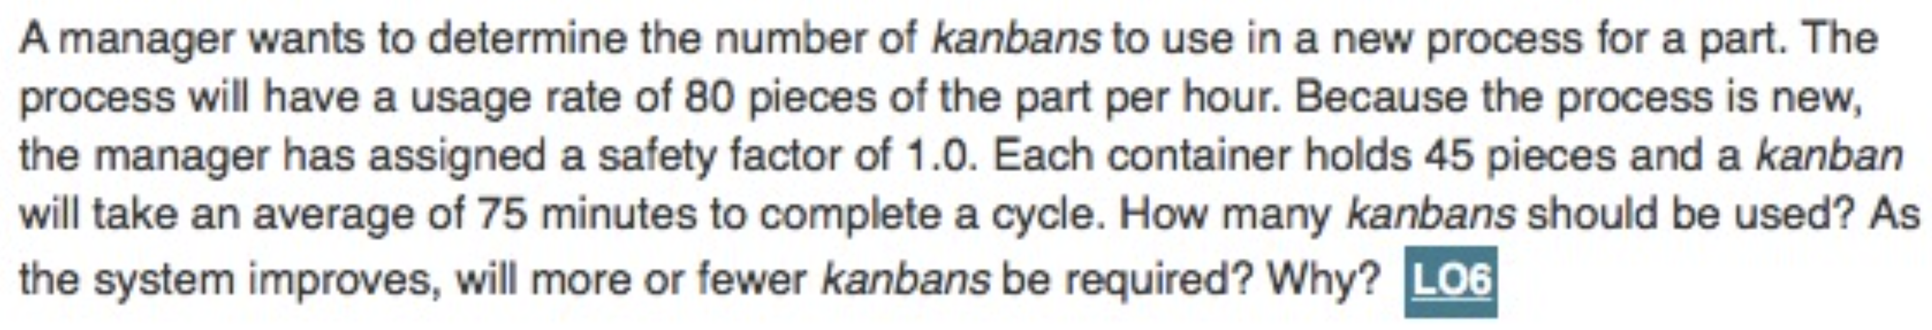

$D=80$ pieces per hour

$X=1.0$

$C=45$ pieces

$T=75$ minutes $=1.25$ hours

$N= ?$

$$N=\frac{DT\left(1+X\right)}{C}=\frac{80\left(1.25\right)\left(1+1.0\right)}{45}=4.4 \left[use 4 of 5 containers\right]$$

As the system improves, fewer containers will be required because wait times, set up times, and process variability will decrease.

# JIT and Lean Production: Kanban 2

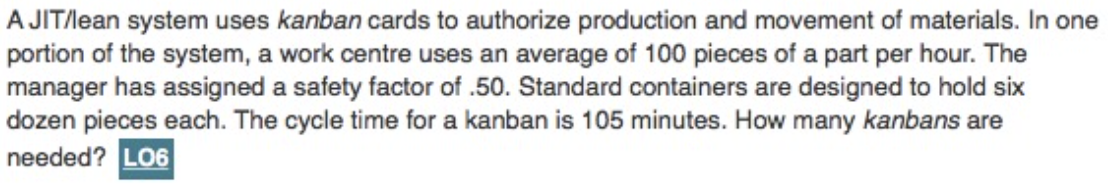

$D=100$ pieces per hour

$X=0.50$

$C=6×12=72$ pieces

$T=105$ minutes $=1.75$ hours

$N= ?$

$$N=\frac{DT\left(1+X\right)}{C}=\frac{100\left(1.75\right)\left(1+0.50\right)}{72}=3.65 \left[round to 4 containers\right]$$

# Aggregate Operations Planning: Forecasts, Total Cost

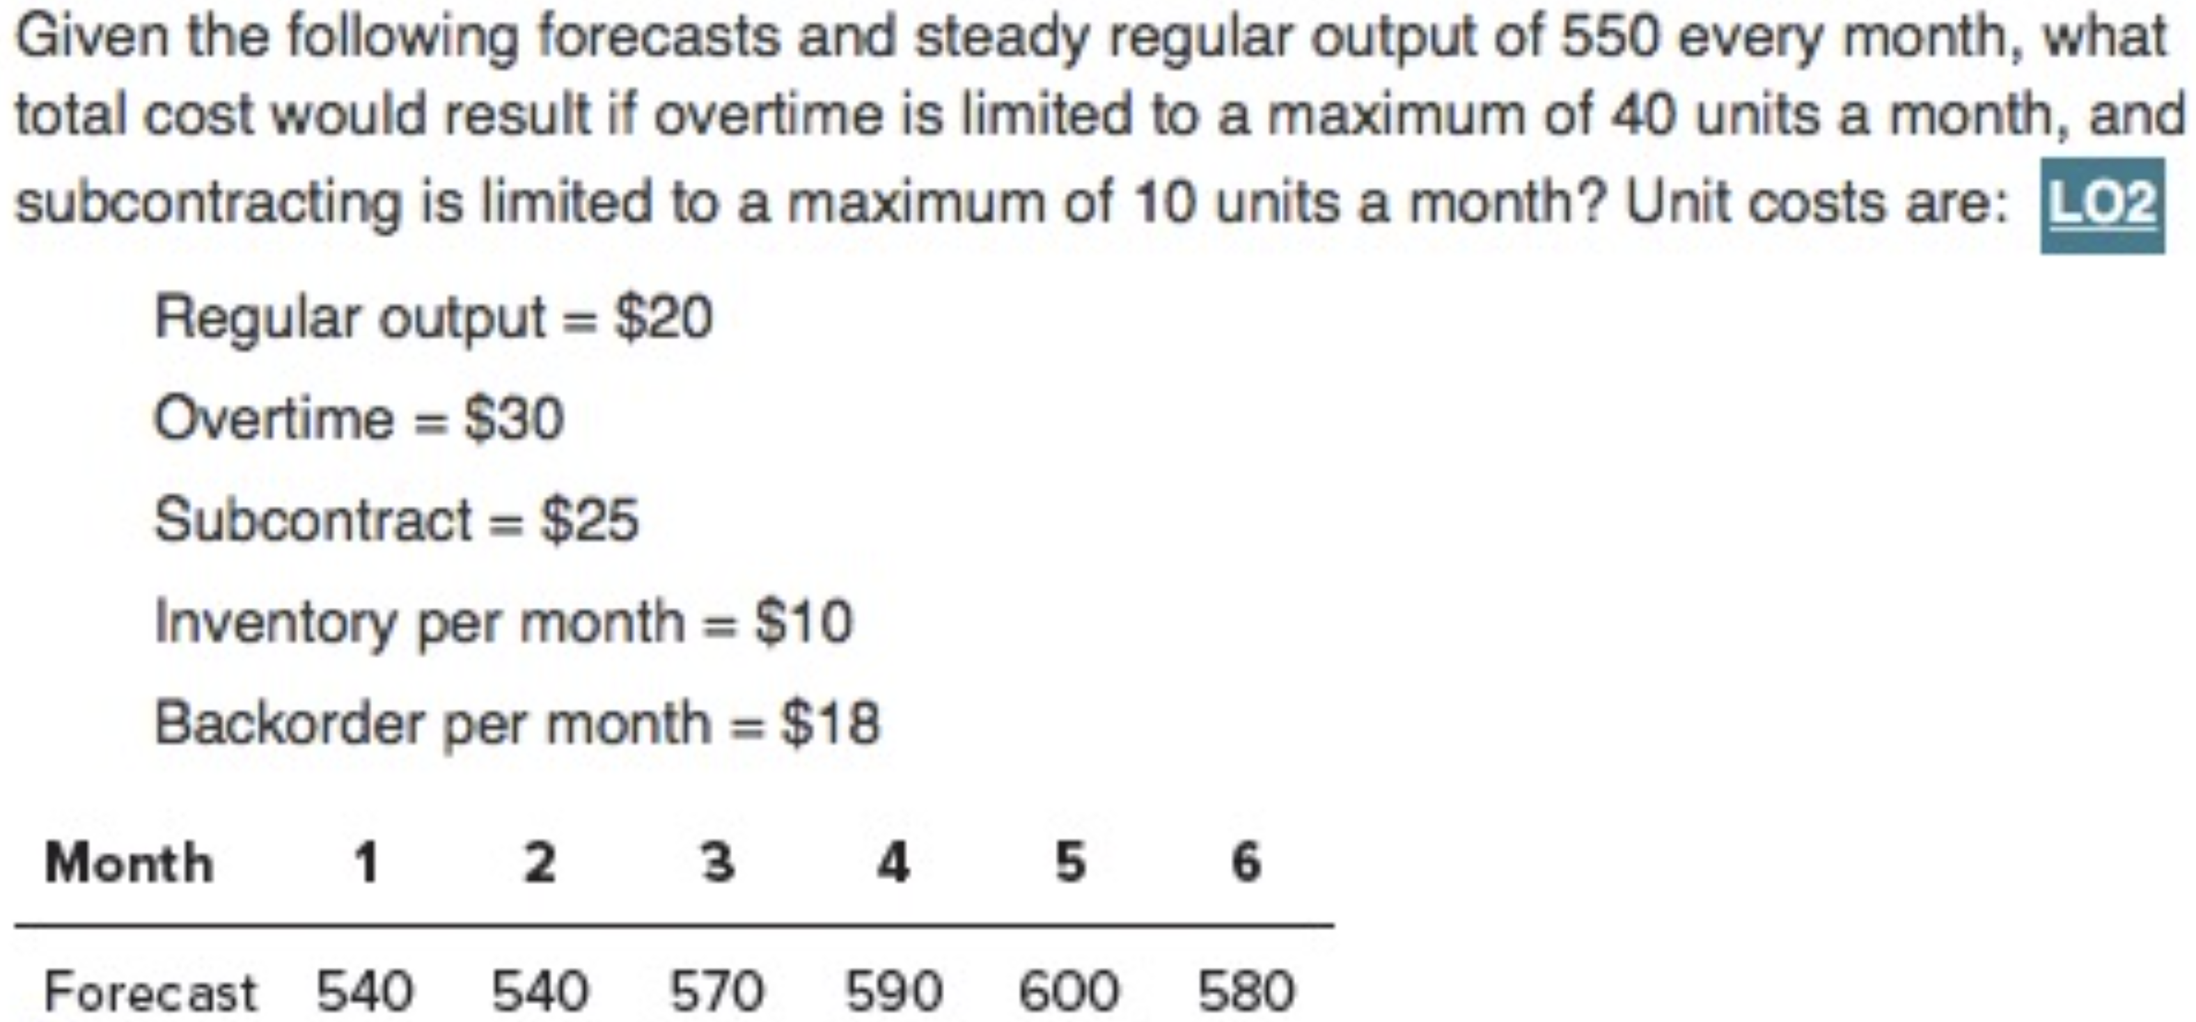

Step 1: Check for backorders.

|  |  |  |  |  |  |  |  |
| --- | --- | --- | --- | --- | --- | --- | --- |
| **Month** | **1** | **2** | **3** | **4** | **5** | **6** | **Total** |
| **Forecast** | $$540$$ | $$540$$ | $$570$$ | $$590$$ | $$600$$ | $$580$$ | $$3,420$$ |
| **Output** | | | | | | | |
| **Regular** | $$550$$ | $$550$$ | $$550$$ | $$550$$ | $$550$$ | $$550$$ | $$3,300$$ |
| **Part Time** |  |  |  |  |  |  | $$0$$ |
| **Overtime** |  |  |  |  |  |  | $$0$$ |
| **Subcontract** |  |  |  |  |  |  | $$0$$ |
| **Output $–$ Forecast** | $$10$$ | $$10$$ | $$-20$$ | $$-40$$ | $$-50$$ | $$-30$$ | $$-120$$ |
| **Inventory** | | | | | | | |
| **Beginning** | $$0$$ | $$10$$ | $$20$$ | $$0$$ | $$0$$ | $$0$$ |  |
| **Ending** | $$10$$ | $$20$$ | $$0$$ | $$0$$ | $$0$$ | $$0$$ |  |
| **Average** | $$5$$ | $$15$$ | $$10$$ | $$0$$ | $$0$$ | $$0$$ | $$30$$ |
| **Backorder** | $$0$$ | $$0$$ | $$0$$ | $$40$$ | $$90$$ | $$120$$ | $$250$$ |

There are backorders in months 4, 5, and 6: $40+50+30=120$ units, so account for them.

Step 2: Calculate total cost.

|  |  |  |  |  |  |  |  |  |
| --- | --- | --- | --- | --- | --- | --- | --- | --- |
| **Month** |  | **1** | **2** | **3** | **4** | **5** | **6** | **Total** |
| **Forecast** |  | $$540$$ | $$540$$ | $$570$$ | $$590$$ | $$600$$ | $$580$$ | $$3,420$$ |
| **Output** | | | | | | | | |
| **Regular** |  | $$550$$ | $$550$$ | $$550$$ | $$550$$ | $$550$$ | $$550$$ | $$3,300$$ |
| **Part Time** |  |  |  |  |  |  |  | $$0$$ |
| **Overtime** |  |  |  |  | $$30$$ | $$40$$ | $$20$$ | $$90$$ |
| **Subcontract** |  |  |  |  | $$10$$ | $$10$$ | $$10$$ | $$30$$ |
| **Output $-$ Forecast** |  | $$10$$ | $$10$$ | $$-20$$ | $$0$$ | $$0$$ | $$0$$ | $$0$$ |
| **Inventory** | | | | | | | | |
| **Beginning** |  | $$0$$ | $$10$$ | $$20$$ | $$0$$ | $$0$$ | $$0$$ |  |
| **Ending** |  | $$10$$ | $$20$$ | $$0$$ | $$0$$ | $$0$$ | $$0$$ |  |
| **Average** |  | $$5$$ | $$15$$ | $$10$$ | $$0$$ | $$0$$ | $$0$$ | $$30$$ |
| **Backorder** |  | $$0$$ | $$0$$ | $$0$$ | $$0$$ | $$0$$ | $$0$$ | $$0$$ |
| **Costs** | | | | | | | | |
| **Regular** | $$\$20$$ | $$\$11,000$$ | $$\$11,000$$ | $$\$11,000$$ | $$\$11,000$$ | $$\$11,000$$ | $$\$11,000$$ | $$\$66,000$$ |
| **Part Time** |  |  |  |  |  |  |  | $$\$0$$ |
| **Overtime** | $$\$30$$ | $$\$0$$ | $$\$0$$ | $$\$0$$ | $$\$900$$ | $$\$1,200$$ | $$\$600$$ | $$\$2,700$$ |
| **Subcontract** | $$\$25$$ |  |  |  | $$\$250$$ | $$\$250$$ | $$\$250$$ | $$\$750$$ |
| **Hire/Layoff** |  |  |  |  |  |  |  | $$\$0$$ |
| **Inventory** | $$\$10$$ | $$\$50$$ | $$\$150$$ | $$\$100$$ |  |  |  | $$\$300$$ |
| **Backorders** | $$\$18$$ | $$\$0$$ | $$\$0$$ | $$\$0$$ | $$\$0$$ | $$\$0$$ | $$\$0$$ | $$\$0$$ |
|  |  | $$\$11,050$$ | $$\$11,150$$ | $$\$11,100$$ | $$\$12,150$$ | $$\$12,450$$ | $$\$11,850$$ | $$\$69,750$$ |

Total cost $=\$69,750$.

# Supply Chain Management: Logistics, Cheapest Total Cost

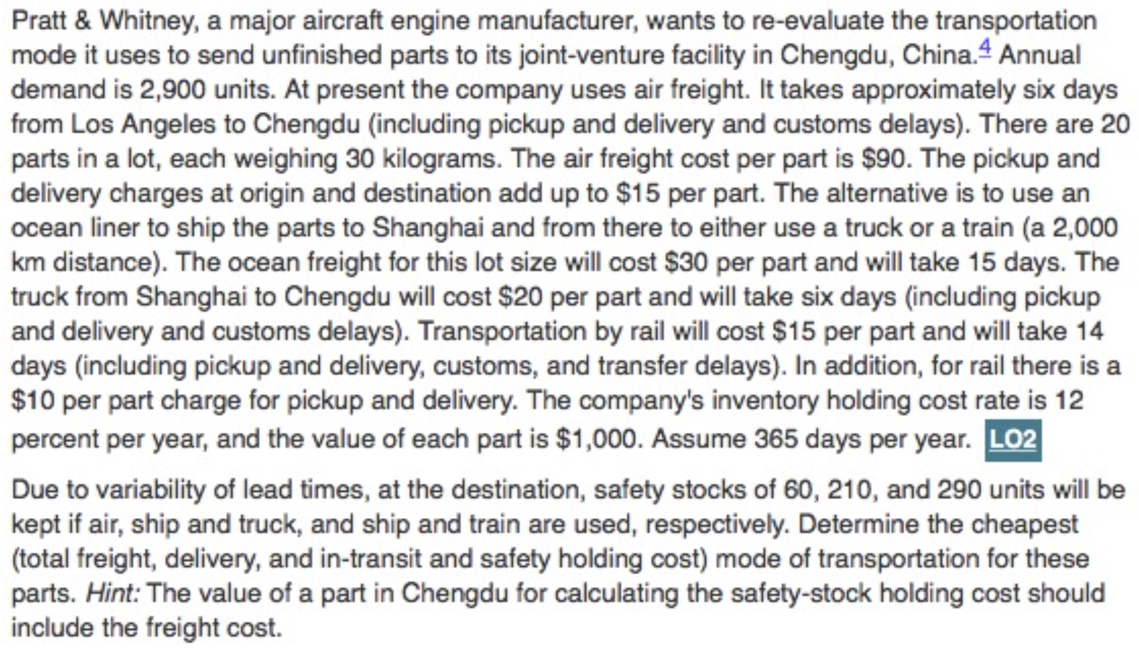

|  |  |  |
| --- | --- | --- |
| **Mode** | **Duration (days)** | **Cost ($) Per Part** |
| Air | $$6$$ | $$90+15=105$$ |
| Ocean, Truck | $$15+6=21$$ | $$30+20=50$$ |
| Ocean, Train | $$15+14=29$$ | $$30+15+10=55$$ |

Annual freight and delivery cost $=$ cost per part $×$ annual demand.

|  |  |
| --- | --- |
| **Mode** | **Annual Freight and Delivery Costs** |
| Air | $$\$105×2,900=\$304,500$$ |
| Ocean, Truck | $$\$50×2,900=\$145,000$$ |
| Ocean, Train | $$\$55×2,900=\$159,500$$ |

Annual in-transit holding cost $=$ value per part $×$ holding rate $×$ $\frac{duration}{365}$ $×$ annual demand.

|  |  |
| --- | --- |
| **Mode** | **Annual In-Transit Holding Costs** |
| Air | $$\$1,000×0.12×\frac{6}{365}×2,900=\$5,720.55$$ |
| Ocean, Truck | $$\$1,000×0.12×\frac{21}{365}×2,900=\$26,460$$ |
| Ocean, Train | $$\$1,000×0.12×\frac{29}{365}×2,900=\$36,714$$ |

Annual safety stock holding cost $=$ safety stock $×$ (value per part $+$ cost per part) $×$ holding rate.

|  |  |
| --- | --- |
| **Mode** | **Annual Safety Stock Holding Costs** |
| Air | $$60×\left(\$1,000+\$105\right)×0.12=\$7,956$$ |
| Ocean, Truck | $$210×\left(\$1,000+\$50\right)×0.12=\$26,460$$ |
| Ocean, Train | $$290×\left(\$1,000+\$55\right)×0.12=\$36,714$$ |

Total cost $=$ Freight and delivery cost $+$ In-transit holding cost $+$ Safety stock holding cost.

|  |  |
| --- | --- |
| **Mode** | **Annual Total Cost** |
| Air | $$\$304,500+\$5,720.55+\$7,956=\$318,176.55$$ |
| Ocean, Truck | $$\$145,000+\$20,021.92+\$26,460=\$191,481.92$$ |
| Ocean, Train | $$\$159,500+\$27,649.32+\$36,714=\$223,863.32$$ |

The cheapest mode of transportation for these parts is by ocean and truck.